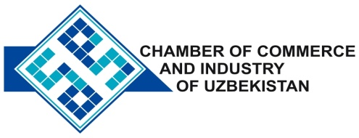

**Commercial offer of Uzbek Products to Foreign Buyer**

Dear Sirs, KP-026

We are pleased to offer you products of the Uzbek Company Ltd «CENTRAL ASIAN CONSTRICTION».

**Information about the company:**

The Company "CENTRAL ASIAN CONSTRICTION" was founded in 2002. The company specializes in the production of multi-layer thermoform able film, disposable tableware and packaging containers.

**List of products:**

Disposable tableware

Adhesive tape - tape

**Benefits:**

Offered by polymeric thermoform able sheets of polystyrene, polypropylene Pat made of primary raw materials and dyes supplied by the manufacturer’s direct contracts, which ensures the availability and stability of price and quality.

**Terms of delivery:** FCA Tashkent

If you are interested, we are happy to provide additional information in accordance with your request.

E-mail: [export@chamber.uz](mailto:export@chamber.uz)

Website: [www.chamber.uz](http://www.chamber.uz)

Export Promotion Department.

Chamber of Commerce of the Republic of Uzbekistan.